President Barack Obama
The White House
1600 Pennsylvania Avenue
Washington, DC 20006

Attorney General Eric Holder
U.S. Department of Justice
950 Pennsylvania Avenue, NW
Washington, DC 20530

July 26, 2012

Dear President Obama and Attorney General Holder:

We write to renew our request that you hold in abeyance petitions for lawful permanent residence filed by U.S. citizens on behalf of their gay or lesbian spouses that would be approvable but for the Defense of Marriage Act (“DOMA”).

As we have stated in previous memoranda to the White House, the Department of Justice (“DOJ”), and United States Citizenship and Immigration Services (“USCIS”), we believe that USCIS has the legal authority to hold green card petitions and applications without adjudicating them until there is a final judicial decision or Congressional resolution in this area. We have also previously outlined the reasons that we feel the hardships caused to immigrant families by DOMA are so great that the administration must act to protect these families.

We are writing now because the circumstances surrounding DOMA have changed considerably since we first raised this issue a year ago. We believe that you should therefore reconsider your prior decision not to hold green cards in abeyance. Specifically, it is now clear that a final judicial determination on the constitutionality of DOMA is imminent. DOMA has recently been found unconstitutional by the First Circuit Court of Appeals as well as California and New York District Courts. Writs of certiorari are being sought in three cases: Bipartisan Legal Advisory Group of the United States House of Representatives v. Gill, 2012 WL 2586935 (U.S.); Office of Personnel Management v. Golinski, 2012 WL 2586938 (U.S.), and Windsor v. The United States of America, 2012 WL 2904038 (U.S.). Notably, the parties seeking cert run the entire spectrum of litigants: in the Gill case, it is the House Bipartisan Leadership Advisory Group (“BLAG”); in Golinksi, DOJ has asked the U.S. Supreme Court to render a decision without first awaiting a Ninth Circuit decision; and in Windsor, the plaintiff has made a similar request to the Supreme Court. With these three petitions for Supreme Court review pending, it is virtually certain that there will be a final ruling on DOMA within a year.

Moreover, Immigration Equality has also filed a federal challenge to DOMA, Blesch v. Holder, on behalf of five lawfully married lesbian and gay immigrant families residing in the Second Circuit. Although we are making every effort to resolve the issues in this case expeditiously to keep these families together lawfully in the U.S., BLAG has filed a letter with the Court indicating its intention to move for a stay in the case. The administration, through DOJ, has indicated that it does not oppose a stay in the matter. BLAG’s letter to the District Court states that the issue presented “on appeal in Windsor is identical to the issue before the Court in this case, namely, whether Section 3 of the Defense of Marriage Act, 1 U.S.C. § 7 (“DOMA”), violates the equal protection component of the Fifth Amendment Due Process Clause.” With this request for a stay, BLAG is asking that the status quo be maintained for the plaintiffs in Blesch until there is a definitive ruling by the Court of Appeals (or presumably the Supreme Court if cert is granted). We, too, are asking that the status quo be broadly maintained – that the green cards for all lesbian and gay immigrant families be neither approved nor denied until there is a final resolution of the constitutionality of DOMA.

In short, it is now clear that the Supreme Court will render a decision on the constitutionality of Section 3 of DOMA within a year. In the meanwhile, if USCIS continues to deny the applications of lawfully married couples, lesbian and gay immigrant families will continue to suffer irreparable harm through forced separations, forced exile, or the accrual of unlawful presence in the United States. Holding green card petitions and applications without adjudicating them will preserve agency resources and prevent real harm to real families until the Supreme Court resolves this issue next year.

We would welcome the opportunity to discuss these issues with you further.

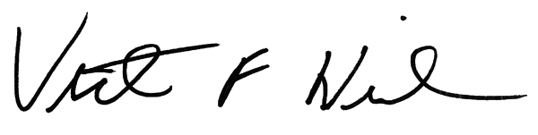
Sincerely,
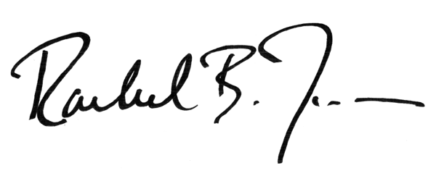
Rachel B. Tiven, Victoria F. Neilson,
Executive Director Legal Director

cc: Valerie Jarrett
Cecilia Muñoz
Kathryn Ruemmler
Stuart Delery
Thomas Perez
Tony West
Kathleen Hartnett
Tyler Moran
Felicia Escobar
Gautam Raghavan
Julie Rodriguez

